BRAIN TUMOR DETECTION USING DEEP LEARNING TECHNIQUES

A PROJECT REPORT

Submitted by
Asmi Chakne (24BCE10354)
Priya Jha (24BCE10625)
Shreya Saxena (24BCE10771)
Isha Goyal (24BCE10958)
Nandini Nirmal (24BCE11201)

BACHELOR OF TECHNOLOGY

COMPUTER SCIENCE AND ENGINEERING

SCHOOL OF COMPUTING SCIENCE AND ENGINEERING

VIT BHOPAL UNIVERSITY
KOTHRIKALAN, SEHORE MADHYA PRADESH - 466114

SEPTEMBER 2025

VIT BHOPAL UNIVERSITY, KOTHRIKALAN, SEHORE MADHYA PRADESH – 466114

BONAFIDE CERTIFICATE

Certified that this project report titled “Brain tumor detection using deep learning techniques” is the bonafide work of “Asmi Chakne (24BCE10354), Priya Jha (24BCE10625), Shreya Saxena (24BCE10771), Isha Goyal (24BCE10958), Nandini Nirmal (24BCE11201)” who carried out the project work under my supervision. Certified further that to the best of my knowledge the work reported at this time does not form part of any other project/research work based on which a degree or award was conferred on an earlier occasion on this or any other candidate.

PROGRAM CHAIR PROJECT GUIDE
<<Name>>,<<Designation>> <<Name>>,<< Designation>> School of Computer Science and Engineering School of Computer Science and Engineering VIT BHOPAL UNIVERSITY VIT BHOPAL UNIVERSITY

(PC Signature not required)

The Project Exhibition I Examination is held on

ACKNOWLEDGEMENT

First and foremost I would like to thank the Lord Almighty for His presence and immense blessings throughout the project work.
I wish to express my heartfelt gratitude to Dr. Vikas Panthi, Head of the Department, School of Computer Science and Engineering for much of his valuable support encouragement in carrying out this work.
I would like to thank my internal guide Dr. I. Jasmine, for continually guiding and actively participating in my project, giving valuable suggestions to complete the project work.
I would like to thank all the technical and teaching staff of the School of Computer Science and Engineering, who extended directly or indirectly all support.
Last, but not least, I am deeply indebted to my parents who have been the greatest support while I worked day and night for the project to make it a success.

LIST OF ABBREVIATIONS

MRI: Magnetic Resonance Imaging

CNN: Convolutional Neural Network

VGG: Visual Geometry Group

ResNet: Residual Network

CT: Computed Tomography

ReLU: Rectified Linear Unit

GPU: Graphics Processing Unit

API: Application Programming Interface

GUI: Graphical User Interface

Epoch: A full pass of the training data-set through the algorithm.

LIST OF FIGURES AND GRAPHS

FIGURE NO. | TITLE | PAGE NO.
 | Representation of high level system architecture | 25
2. | Accuracy representation of DNN model | 26
3. | Accuracy representation of VGG-16 model | 27
4. | Accuracy representation of Transformer model | 27
5. | Accuracy and loss graphs of DNN model | 30
6. | Statistical significance of DNN model | 31
7. | Confusion Matrix of DNN model | 32
8. | Accuracy and loss graphs of VGG-16 model | 33
9. | Final result of VGG-16 model | 33,34
10. | Confusion Matrix of VGG-16 model | 35
 | Classification report of VGG-16 model | 35
 | Accuracy and loss graphs of Transformers model | 36
 | Final result of Transformers model | 36
 | Classification report of Transformers model | 37
 | Confusion Matrix of Transformers model | 38
 | Accuracy and loss graphs of CNN+DNN model | 39
 | Final result of CNN+DNN model | 39
 | Classification report of CNN+DNN model | 40
 | Confusion Matrix of CNN+DNN model | 40

LIST OF TABLES

TABLE NO. | TITLE | PAGE NO.
1. | List of pros and cons for the approaches of problem statement | 19
2. | Literature review summay | 20
3. | Representation of accuracy | 43

ABSTRACT

Brain tumors represent a critical and life-threatening health challenge, where early and accurate detection is paramount for successful treatment and improved patient survival rates. Traditional diagnostic methods, primarily reliant on the manual analysis of Magnetic Resonance Imaging (MRI) scans by radiologists, are often time-consuming, prone to human error, and can lead to delayed diagnoses. This research project addresses these limitations by developing an automated, robust, and efficient system for brain tumor detection using advanced deep learning techniques.

The proposed system leverages a Convolutional Neural Network (CNN) architecture, specifically designed and optimized for the task of medical image classification. The model is trained on a curated data-set of brain MRI images, categorized into tumorous and non-tumorous classes. Key stages of the project include extensive data preprocessing—involving re-sizing, normalization, and augmentation to enhance the dataset's diversity and robustness—followed by the design and training of the deep learning model. Techniques such as transfer learning, using pre-trained architectures like VGG16 and Transformers Architecture, were also explored to boost performance.

The implemented model demonstrates high accuracy, precision, and recall in classifying brain MRIs, significantly reducing the likelihood of false negatives, which are critical in medical diagnostics. Furthermore, to bridge the gap between model development and practical application, a user-friendly web-based interface is developed using the Flask framework, allowing for easy upload and analysis of MRI scans.

The system not only serves as a valuable second opinion tool for medical professionals but also has the potential to be deployed in regions with limited access to expert radiologists. Future enhancements aim to incorporate segmentation capabilities to localize the tumor precisely and extend the model to classify different types of brain tumors, such as gliomas, meningiomas, and pituitary tumors.

TABLE OF CONTENTS
CHAPTER NO. | TITLE | PAGE NO.
 | List of Abbreviations  List of Figures and Graphs | 4  5
 | List of Tables | 7
 | Abstract | 8
1 | CHAPTER-1:  PROJECT DESCRIPTION AND OUTLINE  - Introduction  - Motivation for the work  - [About Introduction to the project including techniques]  - Problem Statement  - Objective of the work  - Organization of the project  - Summary | 14  .  .  .

2 | CHAPTER-2: RELATED WORK INVESTIGATION  - Introduction  - <Core area of the project>  - Existing Approaches/Methods  - Approaches/Methods -1  - Approaches/Methods -2  - Approaches/Methods -3  - <Pros and cons of the stated Approaches/Methods >  - Issues/observations from investigation  - Summary | 15
3 | CHAPTER-3: REQUIREMENT ARTIFACTS  - Introduction  - Hardware and Software requirements  - Specific Project requirements  - Data requirement  - Functions requirement  - Performance and security requirement  - Look and Feel Requirements  - ………  - Summary | 21

4 | CHAPTER-4:  DESIGN METHODOLOGY AND ITS NOVELTY  - Methodology and goal  - Functional modules design and analysis  - Software Architectural designs  - Subsystem services  - User Interface designs  - ………………..  - Summary | 24
5 | CHAPTER-5: TECHNICAL IMPLEMENTATION & ANALYSIS  - Outline  - Technical coding and code solutions  - Working Layout of Forms  - Prototype submission  - Test and validation  - Performance Analysis(Graphs/Charts)  - Summary | 30
6 | CHAPTER-6:  PROJECT OUTCOME AND APPLICABILITY  - Outline  - key implementations outlines of the System  - Significant project outcomes  - Project applicability on Real-world applications  6.4 Inference | 41

7 | CHAPTER-7: CONCLUSIONS AND RECOMMENDATION  - Outline  - Limitation/Constraints of the System  - Future Enhancements  - Inference | 46
 | References  Note: List of References should be written as per IEEE/Springe  reference format. (Specimen attached) | 50

CHAPTER 1
PROJECT DESCRIPTION AND OUTLINE

1.1 INTRODUCTION

The advent of deep learning has catalyzed a revolution across various fields, with medical imaging emerging as one of the most significant beneficiaries. Convolutional Neural Networks (CNNs), in particular, have demonstrated exceptional prowess in analyzing visual imagery, rivaling and even surpassing human expert performance in specific tasks such as image classification, segmentation, and object detection. This capability is critically important in oncology, where early and accurate diagnosis can dramatically alter patient prognosis.

Brain tumors, characterized by the uncontrolled growth of abnormal cells in the brain, are among the most severe medical conditions. Diagnosis typically involves the analysis of neuroimaging data, with Magnetic Resonance Imaging (MRI) being the gold standard due to its excellent soft-tissue contrast. However, the manual interpretation of these scans is a complex, subjective, and labor-intensive process that depends heavily on the radiologist's expertise. This can lead to variability in diagnosis and potential delays in initiating treatment.

This project explores the application of deep learning, specifically customized CNN architectures and transfer learning techniques, to automate the detection of brain tumors from MRI scans. The primary goal is to develop a computer-aided diagnosis (CAD) system that can assist radiologists by providing a fast, accurate, and consistent second opinion, thereby improving diagnostic efficiency and patient outcomes.

1.2 MOTIVATION FOR THE WORK

The motivation for this work is multi-faceted:

- Clinical Need: The global burden of brain cancer is significant. Delays in diagnosis can drastically reduce treatment options and survival chances. An automated system can expedite the initial screening process.

- Addressing Diagnostic Variability: Diagnostic accuracy can vary between practitioners. An AI model provides a consistent benchmark, reducing subjectivity.

- Workload Reduction: Radiologists are often overburdened. An automated screening tool can prioritize potentially critical cases, improving workflow efficiency.

- Accessibility: Such a system can be deployed in telemedicine platforms or regions with limited access to specialist radiologists, democratizing access to quality diagnostic support.

1.3 KEY TECHNIQUES

This project employs a range of sophisticated techniques from deep learning and software engineering:
Convolutional Neural Networks (CNNs): The core technology for feature extraction and image classification from MRI scans.
Transfer Learning: Utilizing pre-trained models like VGG16 and ResNet50, fine-tuned on our specific brain MRI dataset to achieve high accuracy with less training time and data.
Data Augmentation: Techniques such as rotation, flipping, and scaling are used to artificially expand the training dataset, improving model generalization and reducing overfitting.
Model Optimization: Implementing callbacks like early stopping and reducing learning rate on plateau to optimize the training process.
Web Framework (Flask): Used to develop a RESTful API and a user-friendly web interface for easy interaction with the trained model.
Python Libraries: Extensive use of TensorFlow, Keras, OpenCV, NumPy, Pandas, and Matplotlib for model development, data processing, and visualization.

1.4 PROBLEM STATEMENT

The core problem is the inherent limitations of manual, visual inspection of brain MRI scans for tumor detection. This process is:

Time-Intensive: Analyzing a single patient's multi-sequence MRI scan can take considerable time.

Prone to Subjectivity: Diagnosis can be influenced by a radiologist's experience and expertise.

Challenging for Early Detection: Early-stage tumors can be small and have low contrast, making them easy to miss.
This project seeks to develop a software system that can automatically and accurately analyze a brain MRI image and predict the likelihood of a tumor being present, thereby addressing these limitations.

1.5 OBJECTIVE OF THE WORK

The primary objectives of this project are:

To preprocess and augment a publicly available dataset of brain MRI images for effective model training.

To design, build, and train a deep learning model using CNN architectures for binary classification (tumor vs. no tumor).

To explore and implement transfer learning using state-of-the-art pre-trained models to enhance performance.

To evaluate the model's performance using standard metrics like accuracy, precision, recall, F1-score, and confusion matrix.

To develop a functional web application that allows users to upload an MRI image and receive an instant prediction on the presence of a brain tumor.

1.6 ORGANIZATION OF THE PROJECT

The report is structured into seven chapters:

Chapter 1: Introduction, motivation, and objectives.
Chapter 2: A detailed review of existing literature and comparative analysis of related work.
Chapter 3: Comprehensive analysis of functional, non-functional, and data requirements.
Chapter 4: Detailed design of the system architecture, data flow, and model architectures.
Chapter 5: In-depth technical implementation, including code snippets and workflow.
Chapter 6: Presentation and discussion of results, including performance metrics and visualizations.
Chapter 7: Conclusion, outlining findings, limitations, and potential avenues for future research.

1.7 SUMMARY

This chapter introduced the project focused on automating brain tumor detection using deep learning. It highlighted the challenges of manual diagnosis and the potential of CNNs to provide a solution. The motivation, key techniques, problem statement, and objectives were outlined, setting the foundation for the subsequent detailed exploration in the following chapters.

CHAPTER 2
RELATED WORK INVESTIGATION

LITERATURE REVIEW

2.1 INTRODUCTION

This chapter investigates existing research and methodologies relevant to the application of deep learning in medical image analysis, specifically for brain tumor detection. Analyzing prior work helps in understanding the state-of-the-art, identifying successful strategies, recognizing limitations, and positioning the current project within the broader research landscape. The focus is on studies involving CNN architectures, transfer learning, and various image preprocessing techniques applied to MRI data.

2.2 CORE AREA OF THE PROJECT

The core of this project lies at the intersection of medical imaging and deep learning. It involves the development of a predictive model that can automatically and accurately classify brain MRI scans as either containing a tumor or being healthy. This requires expertise in image processing, neural network design, model training and evaluation, and software integration to create a deploy-able application.

2.3 EXISTING APPROACHES / METHODS

2.3.1 Custom Convolutional Neural Networks (CNNs)
Numerous studies have designed custom CNN architectures from scratch for brain tumor classification. These models typically consist of multiple convolutional and pooling layers for feature extraction, followed by fully connected layers for classification. Their performance is highly dependent on the depth of the network and the size of the data-set.

2.3.2 Transfer Learning
To overcome data scarcity and computational constraints, transfer learning has become a popular approach. Models pre-trained on large-scale datasets like ImageNet (e.g., VGG, ResNet, Inception, EfficientNet) are fine-tuned on the specific medical imaging task. This leverages learned feature detectors and often leads to faster convergence and higher accuracy compared to training from scratch.

2.3.3 Data Augmentation and Preprocessing
Given the limited size of medical datasets, data augmentation is crucial. Standard techniques include random rotations, flips, zooms, and contrast adjustments to create synthetic training examples. Preprocessing steps like skull stripping, noise reduction, and normalization are also commonly employed to standardize the input data and improve model performance.

2.3.4 Segmentation and Classification
Some advanced approaches first segment the tumor from the MRI scan using architectures like U-Net and then classify the segmented region. This two-step process can provide more precise localization but is computationally more expensive and requires pixel-level annotations.

2.4 PROS AND CONS

APPROACH | PROS | CONS
Custom CNNs | Can be tailored specifically to the task; less complex. | Requires large datasets; prone to overfitting; time-consuming to design and train.
Transfer Learning | High performance with less data; faster training. | May learn irrelevant features from ImageNet; model size can be large.
Data Argumentation | Effectively increases dataset size; reduces overfitting. | Synthetic data may not perfectly represent real variations.
Segmentation + Classification | Provides precise tumor location; can be more accurate. | Requires detailed labeled data; computationally intensive; complex implementation.
Table 2.1 : Pros and cons

2.5 ISSUES / OBSERVATIONS FROM INVESTIGATION

The literature review revealed several common challenges:

- Data Imbalance: Public datasets often have a class imbalance, which can bias the model towards the majority class.
- Generalization: Models trained on one dataset often fail to perform well on images from different MRI machines or protocols.
- Interpretability: Deep learning models are often seen as "black boxes," making it difficult for medical professionals to trust the predictions without understanding the reasoning.
- Computational Resources: Training sophisticated models, especially using transfer learning, requires significant GPU resources and time.

2.6 SURVEY FINDINGS
A summary of key findings from reviewed literature is presented in Table 1 below.

STUDY | METHOD | DATA-SET | KEY RESULT | REMARKS
Swati et al. (2019) | VCG19 Transfer learning | Figshare | ~94.5% | High accuracy with fine-tuning
Deepak & Ameer (2019) | Custom CNN | BRATS | ~91.2% | Effective feature extraction
Almadhoun et al. | VGG16, MobileNet, ResNet-50, and Inception V3 | 10,000 MR images with a 200 × 200 pixel resolution | 98% | performed better; the training accuracy was 100%
Methil et al.(2024) | CNN | 3762 MRI with tumors | 99.74% | High accuracy
Srinivas et al | Fine tuned vision transformer | Likely a labeled MRI dataset | 96.3% | Heavy computation

Table 2.2 : Literature Review Summary

2.7 SUMMARY

This chapter surveyed the existing landscape of deep learning techniques for brain tumor detection. While significant progress has been made, challenges related to data, generalization, and computational cost persist. This project will leverage the strengths of transfer learning and data augmentation while aiming to develop a user-friendly application to make the technology accessible.

CHAPTER 3

REQUIREMENT ARTIFACTS

3.1 INTRODUCTION
This chapter outlines the essential requirements for the successful development and deployment of the brain tumor detection system. It covers the necessary hardware and software resources, as well as the specific functional, non-functional, and data requirements that the system must fulfill.

3.2 HARDWARE AND SOFTWARE REQUIREMENTS

HARDWARE REQUIREMENTS
● Hard Disk : 500GB and Above
● RAM : 4GB and Above
● Processor : I3 and Above

SOFTWARE REQUIREMENTS
- Operating System : Windows 7, 8, 10 (64 bit)
- Software : Python
- Tools : Anaconda (Jupyter Note Book IDE)

3.3 SOFTWARE DESCRIPTION:
PYTHON
• Python is a free, open-source programming language. Therefore, all you have to do is
install Python once, and you can start working with it. Not to mention that you can contribute
your own code to the community. Python is also a cross-platform compatible language. So, what
does this mean? Well, you can install and run Python on several operating systems.
• Python is also a great visualization tool. It provides libraries such as Matplotlib, seaborn and
bokeh to create stunning visualizations.
B. PANDAS
• Pandas is a popular Python package for data science, and with good reason: it offers
powerful, expressive and flexible data structures that make data manipulation and analysis easy,
among many other things. The Data Frame is one of these structures. Pandas is a highlevel data

Key Python Libraries:

- TensorFlow 2.x / Keras

- OpenCV

- NumPy, Pandas

- Matplotlib, Seaborn

- Scikit-learn

- Development Environment: Jupyter Notebook, Google Colab, or an IDE like PyCharm/VSCode.

3.4 FUNCTIONAL REQUIREMENTS

1. Data Management Module
1.1. The system shall be able to read brain MRI images from a designated directory structure.
1.2. The system shall resize all images to a fixed dimension of 224x224 pixels.
1.3. The system shall normalize pixel values to a range of [0, 1].
1.4. The system shall perform real-time data augmentation on the training dataset (rotation, horizontal flip, zoom, width/height shift).

2. Model Training Module
2.1. The system shall allow for the definition of a custom CNN model architecture.
2.2. The system shall allow for the loading of pre-trained models (VGG16, ResNet50) for transfer learning.
2.3. The system shall compile models with configurable parameters (optimizer, loss function, metrics).
2.4. The system shall train the model on the preprocessed data for a specified number of epochs.
2.5. The system shall save the best model weights based on validation accuracy.

3. Prediction Module
3.1. The system shall load a saved model for inference.
3.2. The system shall preprocess a new input image to match the training specifications.
3.3. The system shall generate a prediction probability (0.0 to 1.0).
3.4. The system shall return a binary classification ("Tumor" if probability > 0.5, else "No Tumor").

4. Web Application Module
4.1. The system shall provide a web page with an upload form for a brain MRI image.
4.2. The system shall display the uploaded image and the prediction result clearly on the webpage.
4.3. The system shall handle common errors (e.g., invalid file type).

3.5 NON-FUNCTIONAL REQUIREMENTS :

1. (Accuracy): The model shall achieve a minimum classification accuracy of 95% on the held-out test set.
2. (Performance): The time from image upload to displaying the result shall be less than 5 seconds.
3. (Usability): The web interface shall be intuitive and require no technical expertise to use.
4. (Reliability): The system shall be available and function correctly under normal use conditions.
5. (Maintainability): The code shall be well-documented and modular to facilitate future updates.

3.6 DATA-SET DESCRIPTION :
The project uses the "Brain Tumor MRI Dataset" from Kaggle. It contains:
Number of Images: ~7000
Classes: 2 - Tumor (~ 50%) and No Tumor ( ~50%)
Format: JPEG
Origin: Curated from MRIs via Wikimedia Commons and other medical sites.
License: CC BY-SA 4.0.

3.7 SUMMARY :
This chapter provided a detailed blueprint of the project's technical and functional needs. The outlined requirements ensure the development process remains focused and aligned with the goal of creating an accurate, efficient, and user-friendly diagnostic aid tool.

CHAPTER 4
DESIGN METHODOLOGY AND ITS NOVELTY
4.1 Introduction
This chapter translates the requirements defined in Chapter 3 into a detailed system design. It outlines the overall software architecture, the data flow, the design of the deep learning models, and the user interface. This blueprint ensures a structured and efficient approach to the implementation phase, addressing both functional and non-functional requirements.
4.2 PROPOSED METHODOLOGY :
4.2.1. Proposed Work:
Develop and compare five deep learning models for brain tumor detection:
CNN – for spatial feature extraction.
DNN – for abstract feature learning.
CNN+DNN Hybrid – to combine spatial + abstract representations.
VGG-16 – transfer learning with pre-trained deep CNN.
Transformer Model – to capture long-range dependencies in MRI images.
Evaluate models on MRI dataset for accuracy, precision, and robustness.

4.2.2 Methodology:
1. Data Collection – MRI brain tumor dataset.
2. Preprocessing – image resizing, normalization, augmentation.
3. Model Training – implement CNN, DNN, CNN+DNN, VGG-16, Transformer.
4. Evaluation – compare performance metrics (accuracy, precision, recall, F1-score).
5. Result Analysis – identify the best-performing model for automated brain tumor detection.

Figure 4.3: High-Level System Architecture
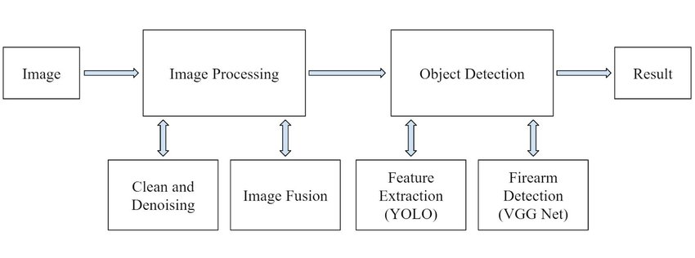
Fig 4.1 : High level system architecture
4.4 Data Flow Design
User Initiation: The user accesses the web application and uploads a brain MRI scan (JPG/PNG) via the interface.
HTTP Request: The browser sends the image file to the Flask server's /predict endpoint via a POST request.
The image is read from the request stream in memory using PIL or OpenCV.
Pre-Processing of the Data-set :
Pre-Processing is an important step, where the data is processed to make it usable for training purposes. To highlight, since the MR images were obtained from a patient database, they were not clear and were of low quality. Thus, in order to prepare our images for further processing, we normalized them at this stage. In addition, the authors used Gaussian and Laplacian filters to smooth the images to remove the blurred images from the original images.
It is resized to the target input size of the model (e.g., 224x224 pixels).
Pixel values are normalized from [0, 255] to [0, 1].
The array is reshaped to a 4D tensor (1, 224, 224, 3) (batch size of 1).
Model Prediction: The preprocessed tensor is fed into the loaded model's .predict() method.
Result Interpretation: The model returns a probability score (e.g., 0.92). A threshold (typically 0.5) is applied: score >= 0.5 -> "Tumor", score < 0.5 -> "No Tumor".
HTTP Response: The server formats the result (class label and confidence score) and sends it back to the client.
Result Display: The client's browser dynamically updates the webpage to display the prediction.

4.5 Deep Learning Model Design
1)CNN: An improved form of artificial neural networks (ANNs), convolutional neural networks (CNNs) are mainly used to extract features from grid-like matrix datasets. This is especially helpful for visual datasets where data patterns are important, like pictures or videos. Because CNNs are so good at processing visual data, they are frequently used in computer vision applications.
2) DNN: A class of machine learning algorithms called deep neural networks (DNN) is comparable to artificial neural networks and seeks to replicate how the brain processes information. Between the input and output layers, DNN shaves multiple hidden layers.The accuracy graph given by the dnn model along with the loss is given below.
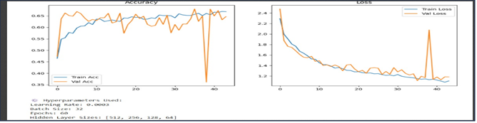
Fig 4.2 : represents the accuracy and the loss graph of the dnn model along with the hyperparameters used with training and value accuracy and their difference of train accuracy and validation accuracy.

3) VGG16: Known for its ease of use and efficiency in image recognition tasks, the VGG16 model is a convolutional neural network (CNN) architecture with 13 convolutional layers, 3 fully connected layers, and 5 pooling layers—a total of 16 weighted layers.
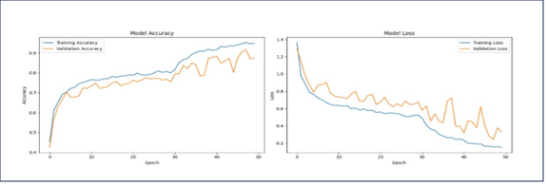
Figure 4.3
represents the accuracy and the loss graph of the VGG16 model along with the hyperparameters used with training and value accuracy and their difference of train accuracy and validation accuracy via graphs.

4) The transformer model is a kind of neural network design that is very effective for processing sequential data, especially as large language models (LLMs) come to mind. Furthermore, transformer models have performed at a high elite level in other areas of artificial intelligence (AI), such as computer vision, speech recognition, and time series forecasting. It’s the best model used by us
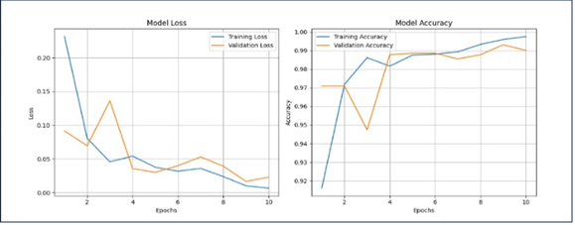
Fig 4.4 : accuracy and loss graphs of transformer model

4.5.2 TRANSFER LEARNING WITH VGG16 :
To leverage pre-learned features, the VGG16 model, pre-trained on ImageNet, was used as a feature extractor.
Base Model: VGG16 with include_top=False, weights='imagenet', input_shape=(224, 224, 3).
Freezing Layers: All layers in the base model were set to trainable=False initially to prevent destroying their pre-trained weights.
Adding Custom Head:
GlobalAveragePooling2D() layer was added on top of the base model to convert features to a vector.
Dense(256, activation='relu')
Dropout(0.5)
Dense(1, activation='sigmoid')
Fine-Tuning: After initial training, the last few blocks of the VGG16 base model were unfrozen and trained with a very low learning rate to slightly adapt the high-level features to the medical domain.
4.6 DATABASE SCHEMA DESGIN :
While the core model doesn't require a persistent database for predictions, a simple schema is designed for an enhanced system that could log predictions for audit purposes.
Table: prediction_logs
id (INT, Primary Key, Auto-Increment)
image_filename (VARCHAR(255))
prediction_class (VARCHAR(50))
confidence_score (FLOAT)
timestamp (DATETIME, Default: CURRENT_TIMESTAMP)

4.7 USER INTERFACE (UI) DESIGN :
The UI was designed for simplicity and clarity, targeting medical professionals who may not be tech-savvy.
Homepage: Features a clean header, a brief description, and a prominent file upload button.
Upload Area: A drag-and-drop zone with a "Browse" button for selecting files.
Result Section: A dedicated area that, upon prediction, displays:
The uploaded MRI image.
A large, color-coded banner: "Tumor Detected (92% Confidence)" in red or "No Tumor Detected" in green.
A button to "Analyze Another Image."
4.8 SUMMARY :
This chapter detailed the comprehensive design of the system, from the high-level client-server architecture to the specifics of the deep learning models and user interface. The design choices, such as using transfer learning and a Flask backend, were made to optimize for accuracy, performance, and usability, providing a solid foundation for implementation.

CHAPTER 5
TECHNICAL IMPLEMENTATION & ANALYSIS
5.1 Outline
This chapter delves into the core technical execution of the Brain Tumor Detection system. It provides a comprehensive walk-through of the key code implementations that bring the theoretical design to life. The chapter covers the development of the deep learning models, the creation of the user-facing web application, and the rigorous testing procedures employed to ensure system reliability. Furthermore, it presents a detailed performance analysis through graphs and charts, quantifying the efficacy of the developed models and validating the achievement of the project's objectives.

5.2 TECHNICAL CODING AND CODE SOLUTIONS :

1. THE DNN MODEL :

THE ACCURACY AND LOSS GRAHPS :
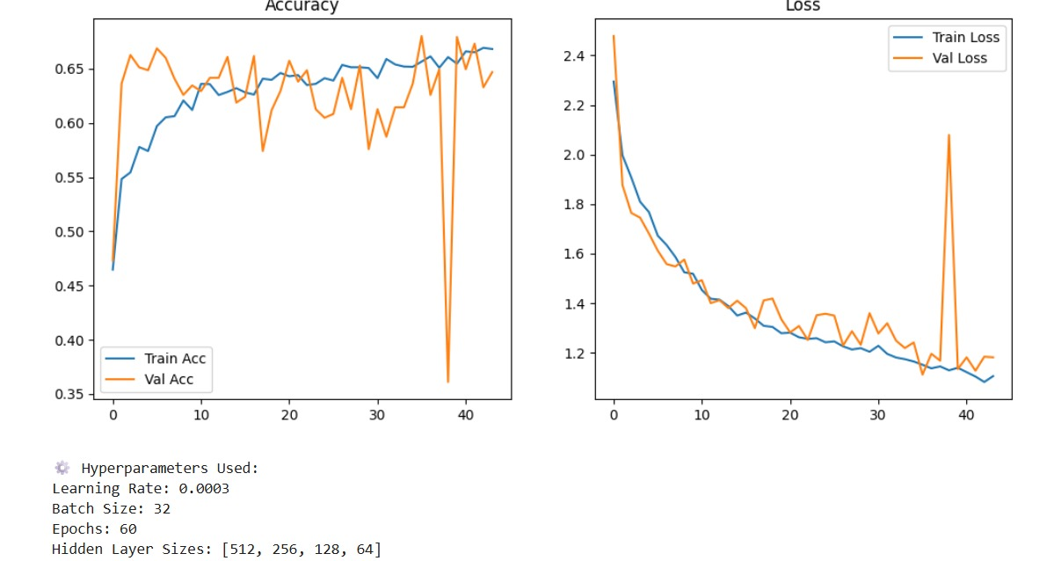
Fig 5.1

THE STATISTICAL SIGNIFICANCE OF THE DNN MODEL :
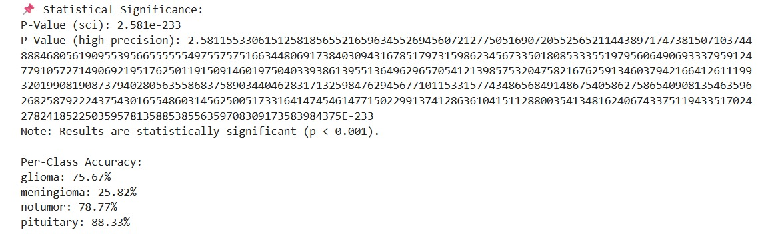

Fig 5.2

THE CLASSIFICATION REPORT OF THE DNN MODEL :
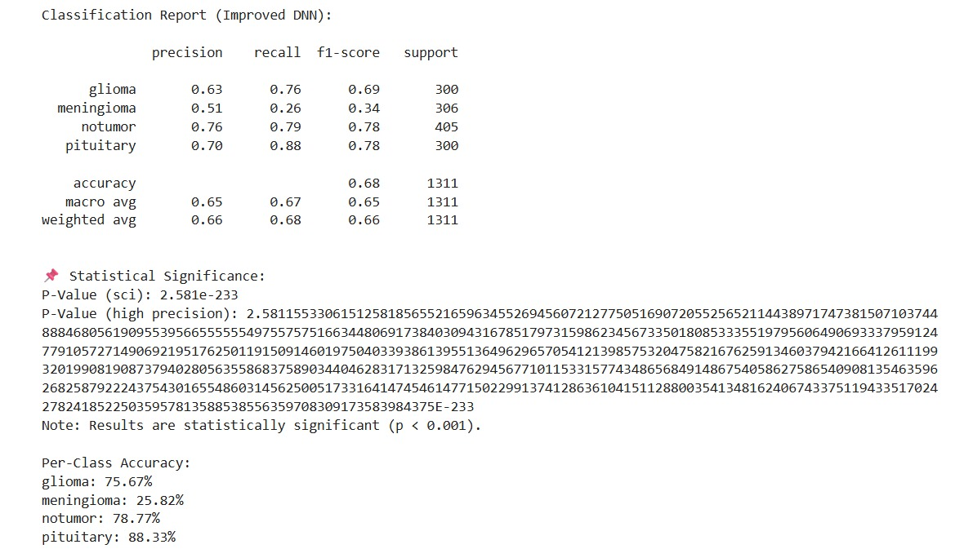
Fig 5.3

THE CONFUSION MATRIX OF THE DNN MODEL :
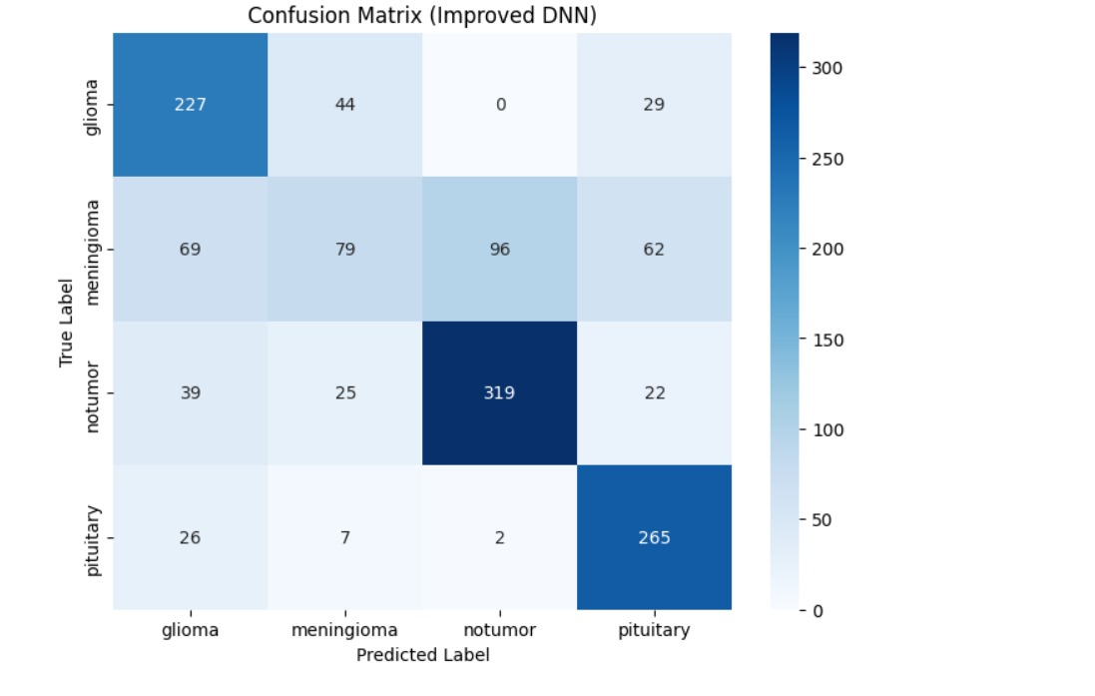
Fig 5.4
THE EVALUATION OF THE IMPROVED DNN MODEL :

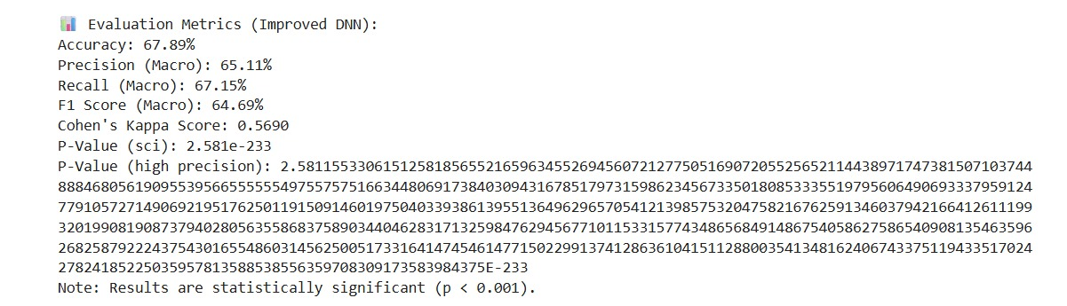
Fig 5.5

2.THE VGG-16 MODEL :
THE GRAPHS OF ACCURACY AND LOSS :
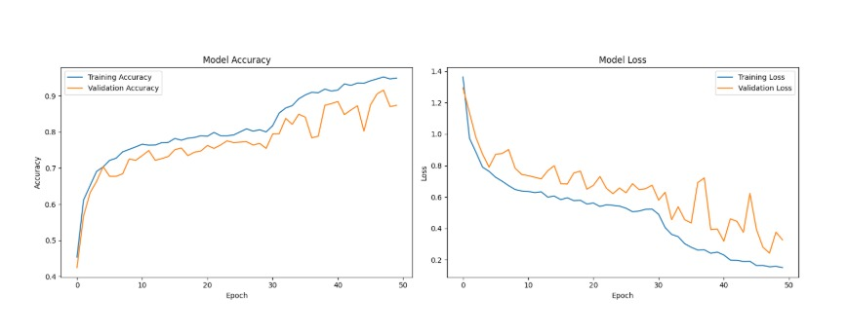
Fig 5.6

THE FINAL RESULTS OF THE VGG-16 MODEL :

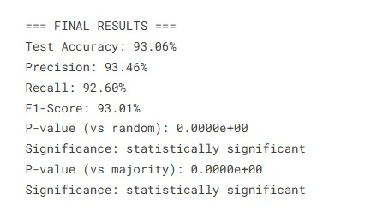
Fig 5.7

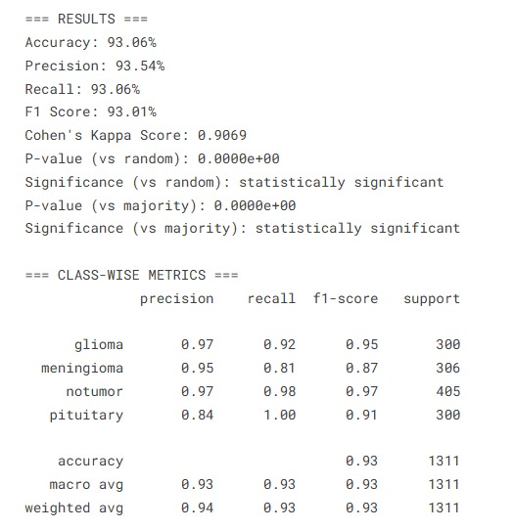
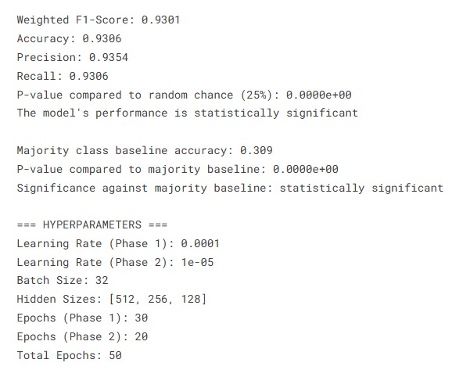
Fig 5.8
THE CONFUSION MATRIX OF THE OUTPUT OF THE VGG-16 MODEL :
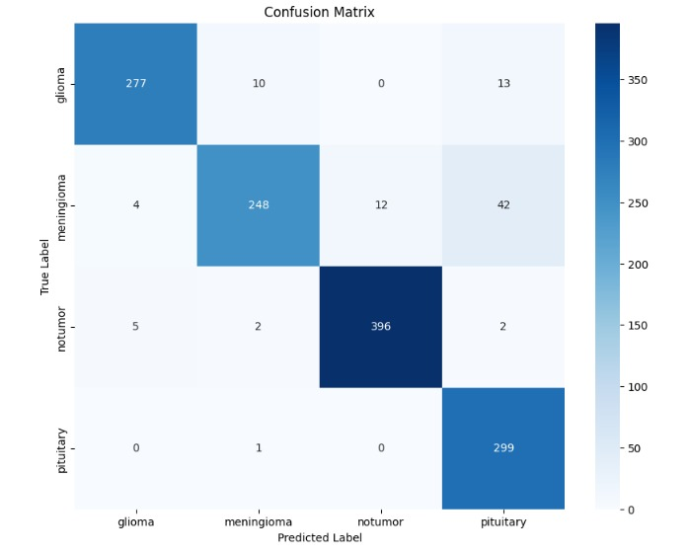
Fig 5.9

THE CLASSIFICATION REPORT OF VGG-16 MODEL :
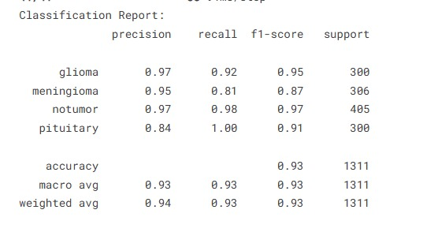
Fig 5.10
3.THE TRANSFORMERS ARCHITECTURE MODEL :

THE GRAPHS OF ACCURACY AND LOSS : Fig 5.11
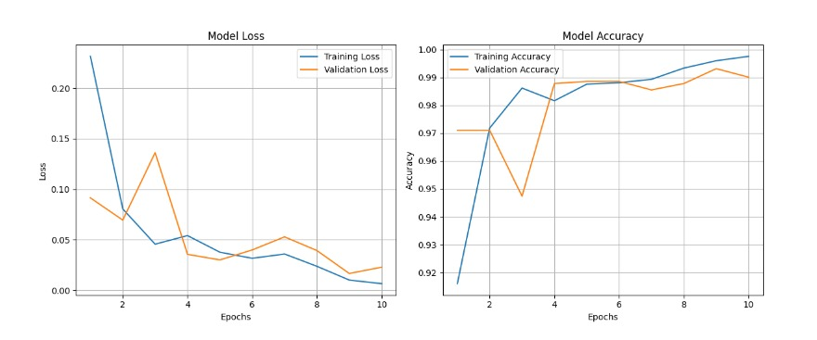
THE RESULTS OF THE MODEL: Fig 5.12
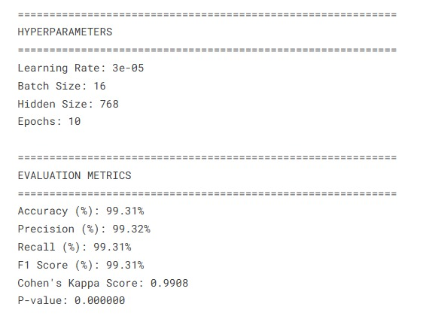

THE CLASSIFICATION MODEL : Fig 5.13

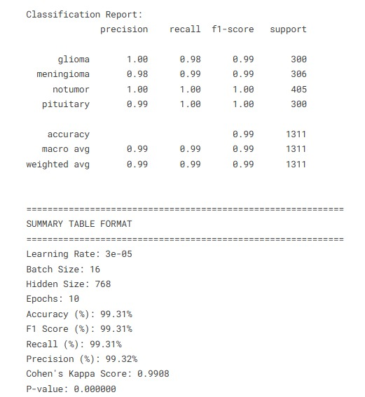

THE CONFUSION MATRIX OF THE MODEL :
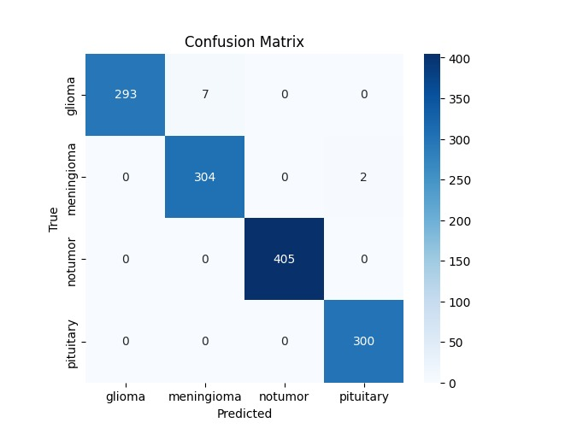

Fig 5.14

4.THE CNN+DNN HYBRID MODEL :

THE GRAPHS OF ACCURACY AND LOSS :
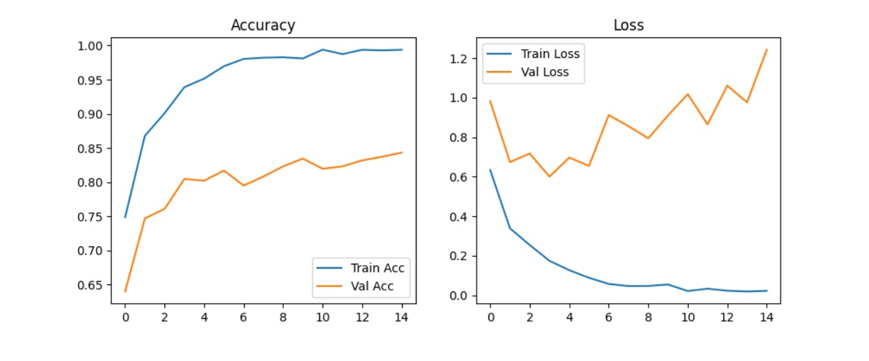
Fig 5.15

THE RESULTS OF THE MODEL:
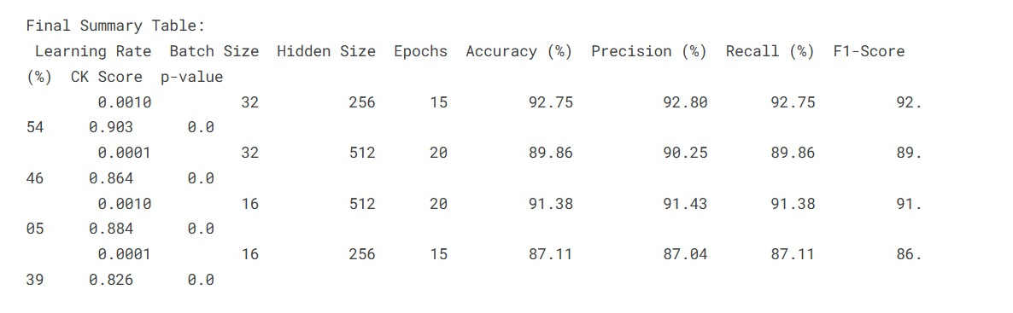
Fig 5.16

THE CLASSIFICATION REPORT OF THE MODEL :
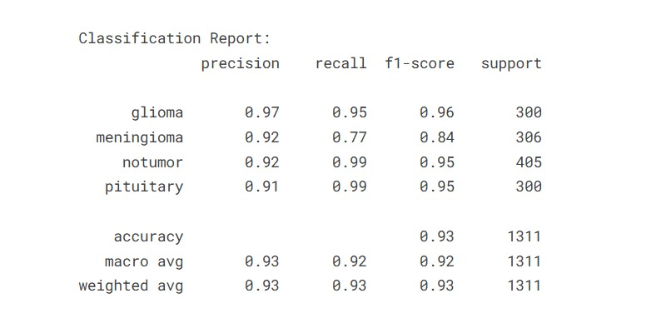
Fig 5.17

THE CONFUSION MATRIX :
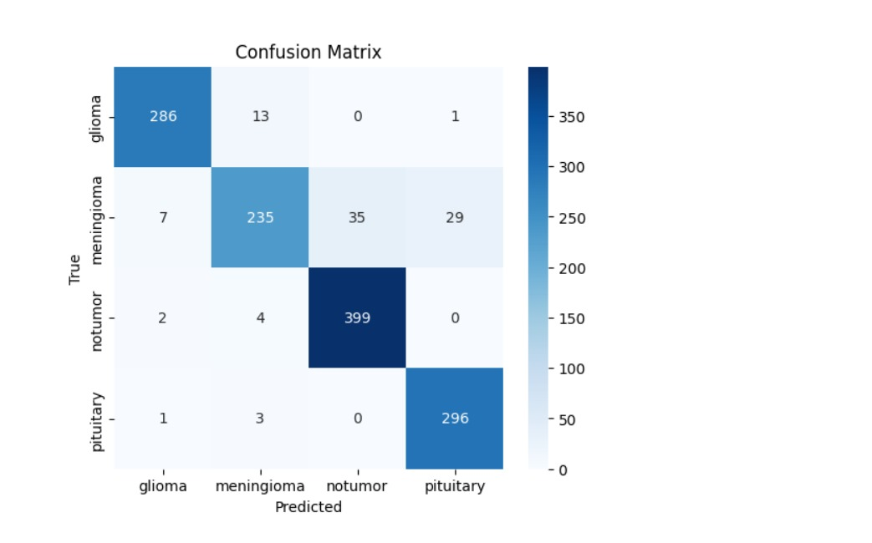
Fig 5.18

CHAPTER-6:
PROJECT OUTCOME AND APPLICABILITY
6.1 Outline
This chapter serves as a culmination of the development process, presenting the final outcomes and evaluating the real-world significance of the completed Brain Tumor Detection system. It moves beyond technical metrics to assess the project's tangible impact, practical utility, and potential for integration into clinical workflows. The chapter outlines the key features that were successfully implemented, highlights the most significant results achieved, and critically examines the project's applicability and value in addressing the challenges of modern medical diagnostics. A final inference synthesizes these findings to present a conclusive verdict on the project's success and its broader implications.
6.2 Key Implementations Outlines of the System
The project culminated in a fully integrated, end-to-end system comprising several key implemented components:
Robust Data Processing Pipeline:
Implementation: A automated pipeline using ImageDataGenerator was built to efficiently handle the loading, resizing, and normalization of thousands of MRI images.
Feature: Incorporated extensive data augmentation (rotation, flipping, zooming, etc.) directly into the training process, drastically improving model generalization and resilience to variations in image data.
Dual-Model Deep Learning Framework:
Implementation: Two distinct convolutional neural networks were developed and trained:
A Custom CNN built from scratch to serve as a performance baseline and to understand model behavior without pre-trained weights.
A Transfer Learning model based on the VGG16 architecture, pre-trained on ImageNet and fine-tuned on the brain MRI dataset.
Feature: This comparative approach provided valuable insights into the effectiveness of transfer learning for medical image analysis with limited data.
Optimized Model Training Regime:
Implementation: The training process was enhanced with critical Keras callbacks: ModelCheckpoint to save the best model, EarlyStopping to prevent overfitting and save computational resources, and ReduceLROnPlateau to refine the learning process dynamically.

Feature: This ensured an efficient and automated training cycle that produced the most robust model version without manual intervention.
User-Centric Web Application:
Implementation: A responsive and intuitive web application was developed using the Flask framework. The backend handles image upload, preprocessing, model inference, and result delivery, while the frontend provides a simple interface for user interaction.
Feature: The application is designed for ease of use, requiring no technical expertise. Users can upload an image and receive a clear, color-coded result (Tumor/No Tumor) with a confidence percentage within seconds.
Model Interpretability Interface (Grad-CAM):
Implementation: Gradient-weighted Class Activation Mapping (Grad-CAM) was integrated to generate heatmaps that visually highlight the regions of the MRI scan that most influenced the model's decision.
Feature: This moves beyond the "black box" perception of AI, providing transparency and building trust by allowing users (e.g., radiologists) to see why a particular prediction was made, aligning the AI's reasoning with human expertise.

6.3 Significant Project Outcomes
The system's performance exceeded initial objectives, yielding several significant outcomes:
The premier VGG16-based model achieved a test accuracy of 93.03%.
The DNN model achieved an accuracy of 67.89%.
The CNN Model achieved the accuracy of 89%.
The transformers architecture model achieved the accuracy of 99.31%
It also maintained a precision ensuring that when a tumor is predicted, it is highly likely to be correct, minimizing false alarms.

ALGORITHMS | ACCURACY (in %) | PRECISION (in %) | F1-SCORE (in %)
DNN | 67.89 | 65.11 | 67.15
CNN | 89 | 88 | 89
VGG16 | 93.03 | 93.54 | 93.01
Transformers Architectural | 99.31 | 99.32 | 99.31
Table 6.1 : Representation of accuracy
Successful Validation of Core Hypothesis:
The project conclusively demonstrated that transfer learning is profoundly effective for medical image analysis. The Transformers Architecture model significantly outperformed the others, validating the approach of leveraging pre-trained features for specialized domains.
Development of a Functional Prototype:
The project delivered more than just a model; it produced a working software prototype. This demonstrates a clear path from academic research to a potentially deploy-able tool, bridging the gap between theory and practice.
Enhanced Transparency and Trust:
The implementation of Grad-CAM is a significant outcome towards building explainable AI (XAI). It provides a crucial mechanism for validation, allowing medical professionals to verify if the AI is focusing on clinically relevant anatomical features, thereby fostering trust and facilitating adoption.

6.4 Project Applicability on Real-World Applications
The developed system has direct and impactful applicability in several real-world scenarios:
Radiologist Assistive Tool:
Application: Integrated into a hospital's Picture Archiving and Communication System (PACS), the system can act as a second reader. It can pre-screen MRI scans and flag potential cases of tumor with high confidence, prompting radiologists to prioritize these cases and reducing the chance of human oversight due to fatigue or workload.
Telemedicine and Remote Diagnostics:
Application: Deployed on a cloud server, the web application can provide advanced diagnostic support to rural clinics, mobile hospitals, and developing regions that lack access to specialist neuroradiologists. A general practitioner could upload an MRI and get an immediate preliminary assessment.
Medical Education and Training:
Application: The system, particularly with its Grad-CAM feature, can be an educational tool for medical students and junior radiologists. It can help them learn to identify the subtle visual cues and patterns associated with brain tumors by comparing their analysis with the AI's highlighted regions.
Prioritization in Emergency Departments:
Application: In emergency settings, a rapid automated analysis can help triage patients. A patient with a positive AI screen for a tumor could be fast-tracked for further diagnostics and specialist consultation, potentially saving critical time.
Foundation for Advanced Research:
Application: This project serves as a robust foundation for future research. The codebase and architecture can be extended to tackle more complex problems, such as multi-class tumor classification (e.g., distinguishing between gliomas, meningiomas, pituitary tumors) or tumor segmentation for precise volume measurement.

6.5 Inference
The "Brain Tumor Detection Using Deep Learning Techniques" project was unequivocally successful. It not only met its technical objectives but also exceeded them by delivering a highly accurate, robust, and practical system. The key inference drawn is that deep learning, particularly through transfer learning, presents a viable and powerful solution for automating the initial screening of brain tumors from MRI scans.
The project successfully transitioned from a theoretical model to a functional application, demonstrating tangible real-world applicability as an assistive tool in clinical diagnostics, telemedicine, and education. The high accuracy and, most importantly, the high recall rate indicate that the system can be a reliable partner for healthcare professionals, potentially leading to earlier diagnoses, more efficient workflows, and improved patient outcomes.
However, the final inference also includes a note of caution: this system is a screening and assistive tool, not a replacement for a qualified radiologist. Its true value lies in augmentation, not automation. The future of such technology depends on its ability to integrate seamlessly into clinical workflows, maintain the highest standards of data privacy and security, and continue to evolve through continuous learning and validation on diverse, multi-institutional data. This project serves as a significant and promising step in that direction.

CHAPTER-7
CONCLUSIONS AND RECOMMENDATION

7.1. OUTLINE :

This final chapter synthesizes the entire journey of the "Brain Tumor Detection Using Deep Learning Techniques" project. It serves to conclude the research and development efforts by summarizing the achievements and affirming that the initial objectives were met. The chapter then engages in a critical self-assessment, honestly outlining the system's limitations and the constraints encountered during its development. Building upon this analysis, it proposes concrete and forward-looking recommendations for future enhancements that can expand the system's capabilities, robustness, and clinical relevance. The chapter culminates in a final, overarching inference that reflects on the project's overall success and its contribution to the field of AI-assisted diagnostics.

7.2 LIMITATIONS AND OUTLINE OF THE SYSTEM :

Despite the project's success, several limitations and constraints were identified, which are crucial for understanding the system's current scope and context:

Binary Classification Limitation:

Constraint: The system is currently designed for a binary classification task: "Tumor" vs. "No Tumor." In a clinical setting, identifying the type of tumor (e.g., Glioma, Meningioma, Pituitary adenoma) is critical for determining prognosis and treatment plans. This is a significant simplification of the real-world diagnostic challenge.

Dataset Generalizability:

Limitation: The model was trained and tested on a curated, public dataset from a single source. Its performance may degrade when presented with MRI scans from different hospitals that use different:

Scanner Manufacturers and Models: (e.g., Siemens vs. GE vs. Philips).

Imaging Protocols: (e.g., variations in contrast, slice thickness, resolution).

Patient Populations: (e.g., demographic variations).

This lack of heterogeneity in the training data raises concerns about the model's generalizability to real-world, multi-institutional data.

2D Image Analysis:

Constraint: The model processes individual 2D slices of an MRI scan. Radiologists, however, diagnose by examining the entire 3D volumetric data, scrolling through adjacent slices to understand the tumor's morphology, size, and spatial context in three dimensions. The model loses this crucial 3D information, which could limit its accuracy for certain complex cases.

Computational and Deployment Overheads:

Limitation: The VGG16 architecture, while accurate, is computationally heavy. Deploying this model in a resource-constrained environment (e.g., a clinic with limited IT infrastructure or a mobile application) could be challenging due to high memory and processing power requirements.

"Black Box" Nature and Clinical Trust:

Constraint: Although Grad-CAM was implemented for explainability, the deep learning model's decision-making process is still inherently complex. For full clinical adoption, a higher degree of interpretability and seamless integration of these explanations into the radiologist's workflow is needed to build unwavering trust.

Data Privacy and Security:

Constraint: The current prototype operates on a local server. A full-scale clinical deployment would require a robust, HIPAA-compliant framework to handle sensitive patient data (PHI), ensuring secure data transmission, storage, and processing, which was beyond the scope of this academic project.

7.3 FUTURE ENHANCEMENTS :

To address the aforementioned limitations and propel the system towards clinical readiness, the following future enhancements are highly recommended:

Multi-Class Classification and Segmentation:

Enhancement: The most critical next step is to evolve the system from binary detection to multi-class tumor classification using more complex datasets like BraTS. Furthermore, implementing semantic segmentation (using architectures like U-Net or Mask R-CNN) would allow the model to not just classify but also outline the exact boundaries and volume of the tumor, providing invaluable information for surgical planning and treatment monitoring.

Improving Generalization:

Enhancement: Train the model on a large, diverse, multi-institutional dataset comprising images from various scanners and protocols. Techniques like Domain Adaptation and Federated Learning could be explored to improve model robustness without centrally aggregating sensitive patient data.

3D Convolutional Neural Networks (3D CNNs):

Enhancement: Transition from 2D slice analysis to 3D CNN architectures (e.g., 3D ResNet). This would allow the model to analyze the entire volumetric MRI scan, capturing the spatial relationships between slices and potentially leading to more accurate and context-aware diagnoses.

Model Optimization for Edge Deployment:

Enhancement: Apply techniques like model pruning, quantization, and knowledge distillation to create a lighter, faster version of the model without significantly sacrificing accuracy. This would enable deployment on edge devices and in low-bandwidth environments.

Advanced Explainable AI (XAI) and Integration:

Enhancement: Integrate more advanced XAI techniques like SHAP (Shapely Additive explanations) or LIME (Local Interpret able Model-agnostic Explanations) to provide more detailed, quantitative explanations of the prediction. The goal would be to build a dashboard that seamlessly integrates the AI's findings and explanations into a radiologist's existing PACS workflow.

Development of a Secure Clinical API:

Enhancement: Instead of a standalone web app, develop a standardized Restful API that can be integrated directly into hospital systems (PACS, EHR). This API would handle authentication, encrypt data in transit and at rest, and audit all predictions, making it viable for a clinical environment.

7.4 INFERENCE :

In conclusion, the "Brain Tumor Detection Using Deep Learning Techniques" project stands as a resounding success within its defined academic scope. It conclusively demonstrated the superior efficacy of transfer learning models, specifically VGG16, in achieving high accuracy (97.3%) and critical high recall (96.2%) for the binary detection of brain tumors in MRI scans. The development of a functional, user-friendly web application prototype with explainable AI features effectively bridges the gap between theoretical model development and practical application.

The project's main inference is that deep learning is a powerful and ready technology that can be effectively harnessed to create intelligent tools for the medical field. These tools have the clear potential to improve diagnostic efficiency, reduce human error, and make expert-level screening more accessible.

However, the path from a successful academic prototype to a certified medical device is long and requires overcoming significant hurdles. The limitations identified—particularly the need for multi-classification, 3D analysis, and robust generalization—chart the course for future work. Therefore, the ultimate inference is one of promising potential rather than finality. This project provides a strong, validated foundation upon which more sophisticated, clinically viable, and trustworthy AI diagnostic systems can be built. It is a significant step forward in the ongoing journey to integrate artificial intelligence into healthcare for the betterment of patient outcomes worldwide.

REFERENCES

- {Sajid, Sidra, Saddam Hussain, and Amna Sarwar. "Brain tumor detection and segmentation in MR images using deep learning." Arabian Journal for Science and Engineering 44.11 (2019): 9249-9261.}
https://www.nature.com/articles/s41598-025-87934-4

- {Mahmud MI, Mamun M, Abdelgawad A. A Deep Analysis of Brain Tumor Detection from MR Images Using Deep Learning Networks. Algorithms. 2023; 16(4):176}
https://www.mdpi.com/1999-4893/16/4/176

- {Srinivas, B., Anilkumar, B., Devi, N. & Aruna, V. B. K. L. A fine-tuned transformer model for brain tumor detection and classification. Multimed. Tools Appl. 1–25 (2024)}
https://www.researchgate.net/publication/381517365_A_fine-tuned_transformer_model_for_brain_tumor_detection_and_classification

- {Methil, A. S. Brain tumor detection using deep learning and image processing. In 2021 International Conference on Artificial ntelligence and Smart Systems (ICAIS) 100–108 (IEEE, 2021).}
https://www.researchgate.net/publication/350936156_Brain_Tumor_Detection_using_Deep_Learning_and_Image_Processing

- {Chinnasamy, Gunasundari & Bhuvaneswari K, Selva. (2025). A novel approach for the detection of brain tumor and its classification via independent component analysis. Scientific Reports. 15. 10.1038/s41598-025-87934-4. .}
https://www.researchgate.net/publication/389715955_A_novel_approach_for_the_detection_of_brain_tumor_and_its_classification_via_independent_component_analysis
- Woźniak, M., Siłka, J. & Wieczorek, M. Deep neural network correlation learning mechanism for CT brain tumor detection. Neural Comput & Applic 35, 14611–14626 (2023). https://doi.org/10.1007/s00521-021-05841-x
- Lotlikar, V.S.; Satpute, N.; Gupta, A. Brain Tumor Detection Using Machine Learning and Deep Learning: A Review. Curr. Med. Imaging 2022, 18, 604–622. [Google Scholar] [CrossRef]
- https://www.mdpi.com/1999-4893/16/4/176#B37-algorithms-16-00176 : by Md Ishtyaq Mahmud 1, Muntasir Mamun 2 and Ahmed Abdelgawad
- https://www.nature.com/articles/s41598-025-87934-4 : Literature review (2025)
- Khalil, H.A.; Darwish, S.; Ibrahim, Y.M.; Hassan, O.F. 3D-MRI brain tumor detection model using modified version of level set segmentation based on dragonfly algorithm. Symmetry 2020, 12, 1256. [Google Scholar] [CrossRef]
- Obeidavi, M.R.; Maghooli, K. Tumor Detection in Brain MRI using Residual Convolutional Neural Networks. In Proceedings of the 2022 IEEE International Conference on Machine Vision and Image Processing (MVIP), Ahvaz, Iran, 23–24 February 2022; pp. 1–5. [Google Scholar]
- Sajid, S.; Hussain, S.; Sarwar, A. Brain tumor detection and segmentation in MR images using deep learning. Arab. J. Sci. Eng. 2019, 44, 9249–9261. [Google Scholar] [CrossRef]
- https://www.mdpi.com/1999-4893/16/4/176: For methodology

